**Django Import/Export Documentation for MemorialMatrix usage.**

The Django import/export tool is able to import records and export records from the admin panel for each model by a simple button located on each model.

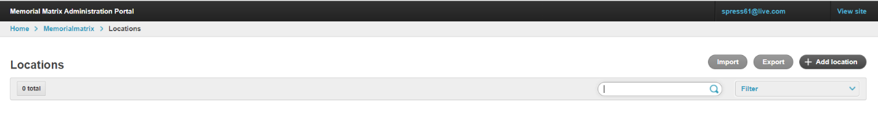

Once either import or export is selected, you have the option to import/export in .csv, .xls, xlsx, .tsv, .json and .yaml.

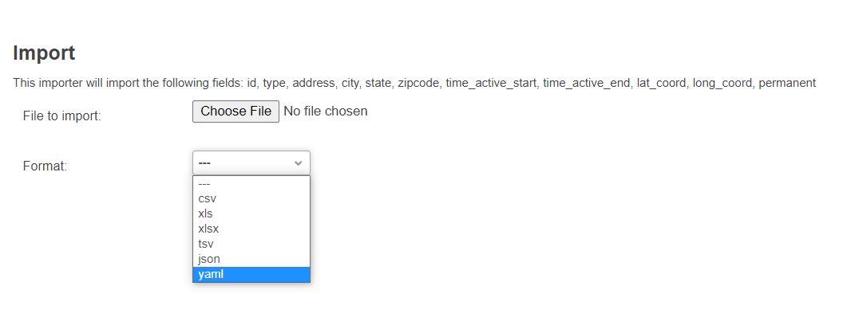

When users/contributors are entering memorials and associated information, some fields are required and some are not, but when as an admin, you are mass importing/exporting data, not all fields will be present. There are no requirements for each field. But, IMPORTANT, the column names must be the same as listed above.

For example, in the black outlined box above, the column time_active_start is listed. In the file you import, the column name must be time_active_start. It cannot be TIME-active_start1 or anything not exactly time_active_start.

Formatting the data as exported is also import. For example, in the field time_active_start, the dates must be formatted as “YYYY-MM-DD” “2022-10-05”. If formatting is off from the required format from the database, an import error may occur. Another example of formatting is the required 2 digit state code as opposed to the full state name. Correct: “NE” Incorrect: “Nebraska”.



An example of an output from Location.

If you export records and make changes to the record, if you have the corresponding ID when importing back, the changes will reflect when you import.

In the above example, the location was edited in excel to be permanent and the time_active_end was changed. You must be aware of any changes being made after exporting and before importing.

Say you have a brand-new record without an ID, an ID will be assigned to any new records being imported.

The id was generated to match the import of a new record. But beware. This can lead to duplication of existing records if there is no ID attached.

**More documentation**

[**https://django-import-export.readthedocs.io/en/latest/index.html**](https://django-import-export.readthedocs.io/en/latest/index.html)